Docker Desktop on Windows

Install Docker Desktop on Windows Home machines using the WSL 2 backend.
WSL2 :
Windows Subsystem for Linux (WSL) 2 is a full Linux kernel built by Microsoft, allowing Linux containers to run natively without emulation.
Docker Desktop Installation:
- Download docker desktop installer from Dockerhub by using below link;
https://hub.docker.com/editions/community/docker-ce-desktop-windows/
- Select “Get Docker” highlighted tab

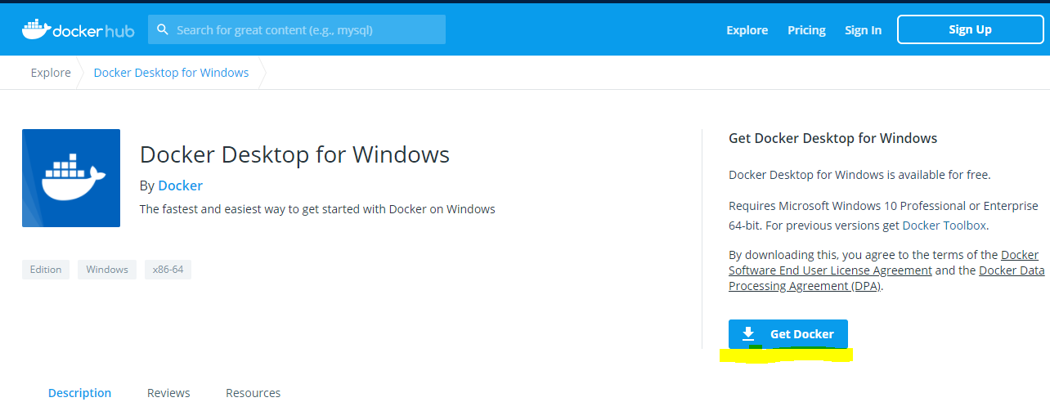

- After download, double click the docker desktop installer application to install it.
- During Installation, select all the checkbox in the configuration setup,

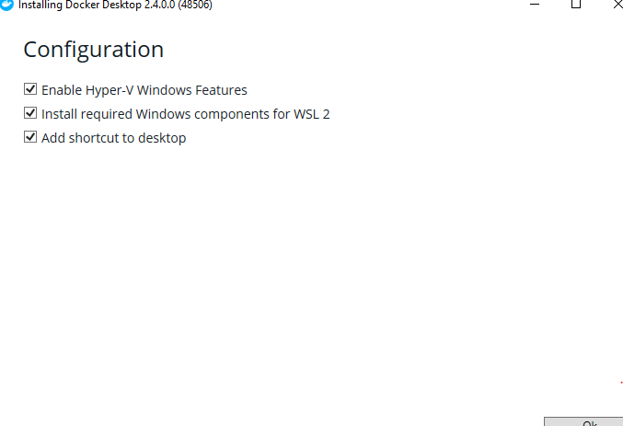
- Open Windows features and select “Turn windows features on or off “. In that feature, select the “Hyper-V” checkbox and click ok button.

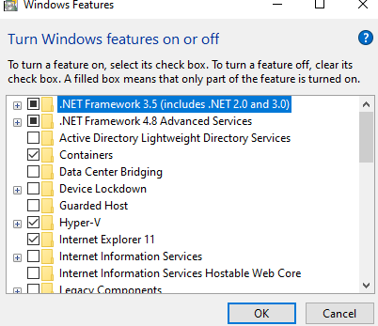

- Open terminal or powershell to check the version by the command,
#docker - -version

Testing Docker Desktop
- In Terminal, run the command “ docker search nginx”
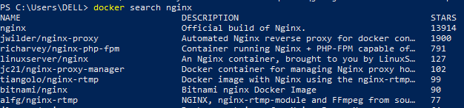

- To get a nginx web server , enter a command ,

“docker pull nginx”

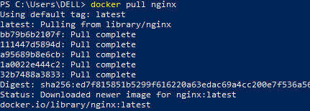

- “#docker images” – to check the docker images
- To run a docker container by using the command,

“ docker run –d –p 80:80 nginx:latest”

- To check the container is running or not by using the command,

“docker ps”

- Now open the docker desktop application and select “ open in browser “ option in the running

container to see the output,





Task Scheduler
- Open the task scheduler application in windows machine,
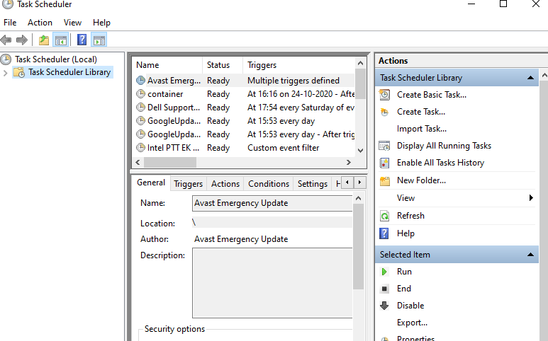
- In the scheduler, select the “create basic task “ in Action part.

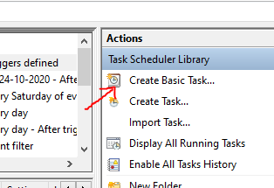
- Give the name and description in the task,

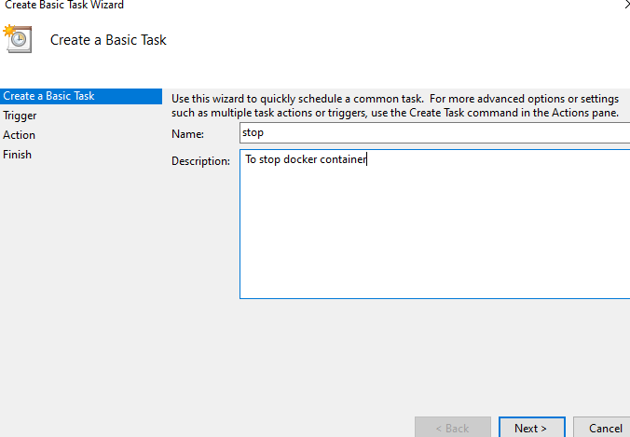

- In Task Trigger section , select the task type depends upon the requirement

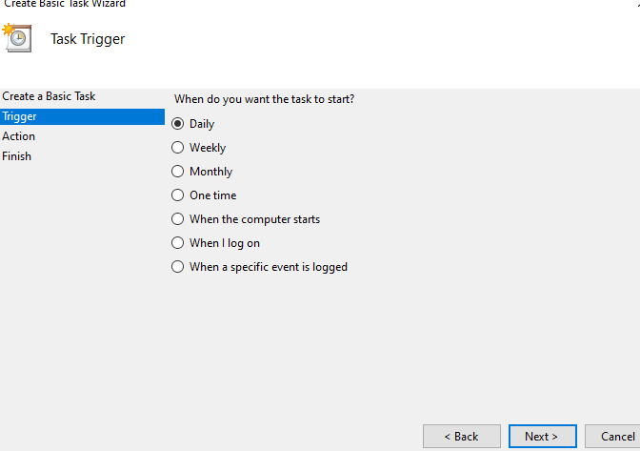

- In Action tab, choose “ start a program “ option

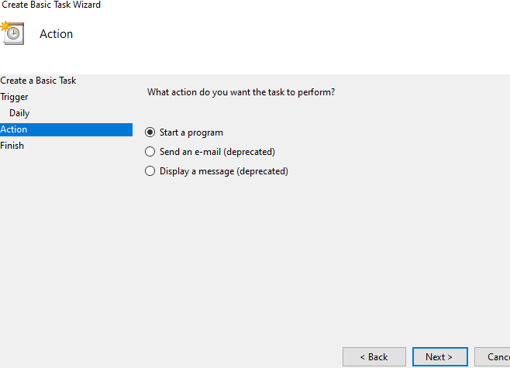

- Enter path/command in “ program/script” section to schedule a task,
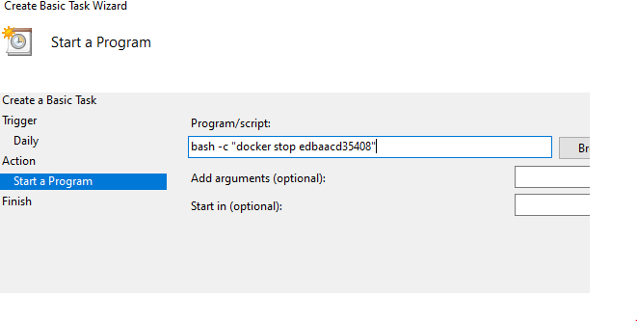

- Finally, click “Finish” button to schedule a task to stop docker container.

